

**Overview:**

Traditionally, loan approval decisions in financial institutions have been made through manual evaluation processes that rely on subjective criteria. This approach often leads to inconsistent outcomes and an increased risk of loan defaults. By harnessing the power of machine learning, we can revolutionize the loan approval process, making it more efficient, objective, and data-driven.

The primary objective of this project is to develop a robust machine learning model capable of accurately predicting loan approval decisions. By leveraging historical loan application data, the model will identify intricate patterns and relationships, enabling it to determine whether a loan should be approved or rejected.

Automating the loan approval process through machine learning techniques offers numerous advantages. It streamlines decision-making, eliminating the need for time-consuming manual evaluations. Additionally, the model's data-driven approach ensures consistent and objective decisions, minimizing the risk of human bias or errors.

Ultimately, the successful implementation of this project will empower financial institutions to make informed loan approval decisions swiftly and accurately. This, in turn, will mitigate the risk of defaults, enhance profitability, and foster a more efficient and reliable lending ecosystem.

**Instructions:**

Begin by importing essential Python modules including pandas, numpy, matplotlib, seaborn, and scikit-learn. Read the loan approval dataset into a Pandas DataFrame and rename columns while preprocessing data, such as converting 'loan_status' to binary values (1 for 'Approved', 0 otherwise). Explore the dataset by analyzing approved loans and calculating the correlation matrix to understand feature relationships. Proceed to model development, considering algorithms like Logistic Regression, Gradient Boosting, Decision Tree Classifier, and Random Forest to predict loan approval decisions based on dataset features.

Finally optmise high accurate models and analyse significant factors affecting Loan approval

**Data Sources:**

**Dataset Source :** https://www.kaggle.com/datasets/architsharma01/loan-approval-prediction-dataset

**Complete Machine Learning Guide to Parameter Tuning in Gradient Boosting (GBM) in Python :** [Gradient Boosting | Hyperparameter Tuning Python (analyticsvidhya.com)](https://www.analyticsvidhya.com/blog/2016/02/complete-guide-parameter-tuning-gradient-boosting-gbm-python/)

**Code References: loan_approval.ipynb**

**File List:**

**Visualizations:**

Our project features a range of visualizations, including but not limited to:

* Barchart -showing relationship between Loan status and CIBIL Score

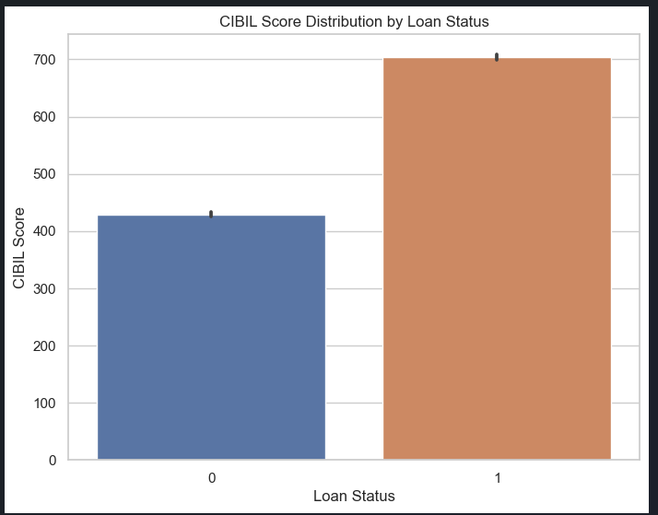

* **Piechart -Top 10 feature importances of a Loan approval decision**

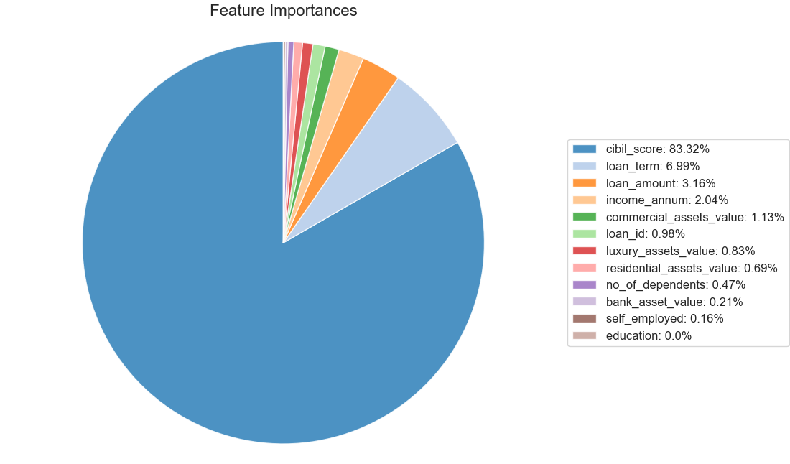

* **Linear regression –** Relationship between loan approval status and CBIL score 